What’s Happening on July 22nd? 2
What is a Charrette and How Will I Participate? 3
How Will This Concept Be Applied to Our Land Use Project at HUMC? 3
How Should I Think About My Choices for the HUMC Campus? 4
What Are the Options for Development? 4
Senior Living 4
Medical/Dental Facilities 4
Affordable/Workforce Housing 4
Hope House 4
Frequently Asked Questions 5

What’s Happening on July 22nd?
On the morning of July 22nd, members of HUMC will be gathering at 9:00am to begin the process of determining what we are going to do to our +28-acre campus. As a congregation, we are blessed to be on this land in the middle of Huntersville. It is our responsibility to be good stewards of this property.
HUMC moved to this campus in April 2008 and, since then, very few changes have been made. Most passersby would only recognize the addition of a new sign, perhaps some larger trees and the removal of the “white house”, also known as the “Scout House.”
Those attending on July 22nd will participate in a facilitated process known as a “charrette.” During this charrette, everyone will have the opportunity to express what they would like to see placed on the HUMC campus.
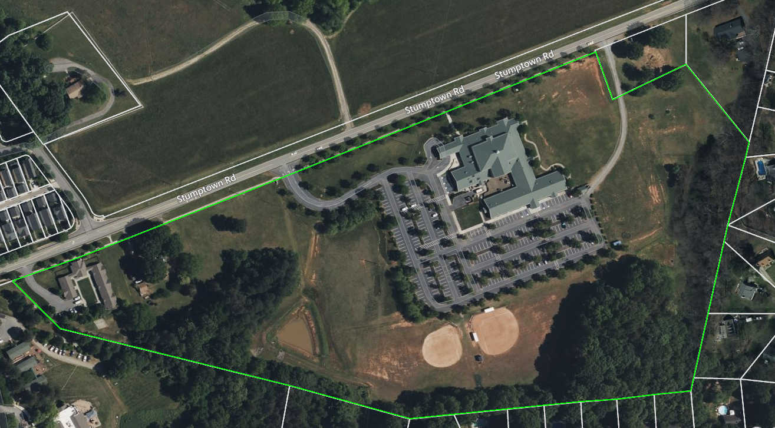

What is a Charrette and How Will I Participate?
A charrette is a facilitated exercise that quickly brings a large group of individuals to a particular outcome.
A quick search of the internet reveals these descriptions of a charrette and its objectives:
- A design charrette is a collaborative meeting during which members of a diverse team collaborate and sketch designs to explore and share a broad diversity of design ideas.
- A design charrette is an intensive workshop involving the participation of all the members. In a complex project, the group is often divided into breakout groups, with each having a different problem or challenge. These breakout groups sit together and brainstorm to get a solution, which is then presented to the group.
- A key objective of a design charrette is to reduce the time required for planning and conceptualization. A series of brainstorming sessions is held, followed by sketching/similar exercises and feedback sessions. This helps to bring all inputs and suggestions to the table. Since multiple sub-groups are working simultaneously, the result is often a well-rounded design that incorporates the best suggestions and irons out the bottlenecks.

How Will This Concept Be Applied to Our Land Use Project at HUMC?
- On July 22nd, we’ll gather as a congregation in either the Fellowship Hall or the Worship Center, depending on the number of participants. Our partners at Wesley Development will facilitate the session.
- The participants will be divided into groups of five to eight people.
- Each group will be given a large map of the campus and pieces of paper that represent “things” that could be located on the campus. These things might include a pavilion, community garden, walking trail or commercial developments (for example, senior living facilities, medical/dental facilities, or workforce/affordable housing).
- Each group will place these “things” on their map and propose their plans for the Church campus. The maps will then serve as congregational input to Wesley Development.
- At the conclusion of the charrette, Wesley Development will consider all congregational input from the maps, and will return to HUMC with three to five recommendations based on that input.

How Should I Think About My Choices for the HUMC Campus?
It’s a good question and one that should be considered thoughtfully. As we have progressed through the Land Use Study, we have been mindful of the congregation’s objectives. You’ve expressed many thoughts about what we should do with our land and, when analyzed, those thoughts tend to fall into one of the following categories:
- Achieving long-term financial stability – This would include things like paying down the existing debt and/or generating additional income streams.
- Reaching out to and serving the needs of the surrounding community – This would include items like providing daycare or tutoring services, or specialized services for the elderly.
- Addressing the expressed needs of the congregation – This includes, for example, a pavilion or community garden, or expanding fields/courts for our sports ministry.

It is fair to say that, as a congregation, we would like to do all of these things. Individually, though, we may prioritize things differently. The collective priorities of the congregation will be revealed through the charrette process.

What Are the Options for Development?
The following are options that are being considered and are in addition to those that HUMC might want for itself (community garden, pavilion, sports fields/courts, etc.). These options are based on discussions held during the congregational meetings, as well as those with third parties that have approached HUMC.

Senior Living
This can take the form of Independent Living, Assisted Living, Memory Care, or any combination of the three. There is always a significant demand for this type facility. It would also provide a significant annual income stream.

Medical/Dental Facilities
Medical/Dental facilities would be attractive, since the lot across the street from HUMC will be the site of a middle school. This would be a convenient option for parents to access medical or dental care for their children. This would also provide a significant income stream.

Affordable/Workforce Housing
Several organizations, including the Town of Huntersville, have inquired about using some portion of our property for this type of housing. While there is an income stream associated with it, it might not be as high as either a Senior Living or Medical/Dental facility.

Hope House
Hope House is a local ministry that assists women who have fallen on hard times to gain independence. One of their programs helps women transition to independent living by providing small cottage homes to allow residents to acclimate to the responsibilities and routines of living on their own and/or owning a home. Hope House has expressed interest in building these transitional cottages on HUMC property. This is an outstanding ministry that assists local women in need.

Frequently Asked Questions
- What is a “land lease” and what are the advantages to HUMC?
A land lease allows a third party to occupy – often for commercial purposes – land that they don’t own through a leasing arrangement. In the case of HUMC, a developer could be offered some parcel of our property for the purpose of developing a senior living facility. The developer would absorb the cost of any development and then pay HUMC for the use of the land through a leasing arrangement. The lease could be for 30-40 years. At the end of the lease term, the property is turned back to HUMC, the lease could be renegotiated, or the land could be leased to another third party.

- If HUMC generates income streams as a result of any commercial development, will that eliminate any future need for a capital campaign?
Generating additional income streams should be viewed as another “lever” that HUMC has at its disposal when it comes to financial planning. Other levers will continue to exist, such as capital campaigns, growing the congregation, increasing personal giving or charging for use of the building.

- On July 22nd, are we required to stay for the entire session?
Yes, we are asking that you stay for the entire session. You will be part of a team that is “designing” what you want to see on our campus and, as such, we’d like you to be present for the entire session. You will also have an opportunity to view what other teams have developed. We would like this to be a congregation-driven event and are asking that you commit to being present for the duration. We expect it to be about three hours in length.

- During the charrette, we’ll be describing what we would like to see on our land. How will those choices be determined?
The choices will be based on the input that we’ve already received from the congregation through the congregational meetings held in May 2023, as well as the various surveys we’ve shared with the congregation.

- Are we making the final decisions for our land on July 22nd?
The short answer is no. Our partners at Wesley Development will take the input from the charrette and deliver back to HUMC three to five potential land use plans. HUMC will determine what the final plan for the campus will be.

- If we choose a third party to develop some of our land, when will that start?
The best answer would be as soon as possible. However, any form of development is an involved process with many moving parts, in addition to working with the Town of Huntersville. Once we’ve determined a direction, it could take anywhere from 6-18 months to get started.

- Will the interior of the existing building be part of the charrette?
Although there are things that can be done to optimize our use of the existing facility, this won’t be addressed during the charrette on July 22nd. That will be addressed at some later time.

- Will the Western North Carolina Conference have a role in what HUMC does with its campus?
The conference will need to provide final approval for anything we do with the HUMC campus. This will happen in accordance with the guidelines described in the Book of Discipline, which governs the activity of the United Methodist Church. A copy can be found online or in the Merryman Room library.

- If HUMC proceeds with any commercial development, will that require zoning changes?
HUMC’s land is currently zoned for residential use. Zoning changes will be required.

- Beyond the existing building, how much of the HUMC campus would be considered usable for some form of development?
Approximately 19 acres is available for development.

